All-in all
Contents
Before you start 2
Route and description of the effects of the nature spots 2
Navigation 4
To the greeting of the nature goddess at her ‘temple’ 5
Greeting the nature goddess at her ‘temple’ 5
Towards the entrance formed by the two beech trees 6
The entrance of the two beech trees 7
To the three birches 7
The three birch trees 8
Towards the two oak trees, the first transformation point 8
The two oaks, the first transformation point 9
To the place of recognition of nature beings 9
The place of recognition of nature beings 10
To the large tree stump 11
The large tree stump 11
To the passage to the Gaja point 12
The passage to the Gaja point 13
To the Gaja point, the second transformation point 13
The Gaja point, the second transformation point 14
Towards the spruce lane, the third transformation point 14
The spruce lane, the third transformation point 15
Towards the juniper bushes 16
The juniper bushes 17
Towards the burning place 18
The burning place 18
To the large beech tree 18
The large beech tree 20
Back to the Lageweg car park 21

Before you start
Have you remembered to bring something to take notes with, so you can look back on your experiences at these nature spots later?
If you wish, do you have the option of setting a time limit for each spot, so that you don’t have to keep an eye on the time and can still complete the whole experience properly? Five to seven minutes per spot is fine, except for the nature temple at the start – you only need to stay there briefly.
At each nature spot, find a spot where you’d like to stand or sit, and read the attached description of that specific spot’s effect.
To allow the nature spots to work their magic, a quiet, receptive, meditative attitude is ideal.
You can create a small gift for the goddess at the nature temple right there and then. You might consider things such as a spoken wish, a poem, a song, beautiful sounds, a loving touch…
If the weather is wet, it may be useful to bring something with you so that you can sit down at the nature spots.

Route and description of the effects of the nature spots
Below, for each spot, you’ll find directions on how to get there, along with a description of that nature spot’s specific effect. The description of the effect is in italics so that it’s easy to spot.
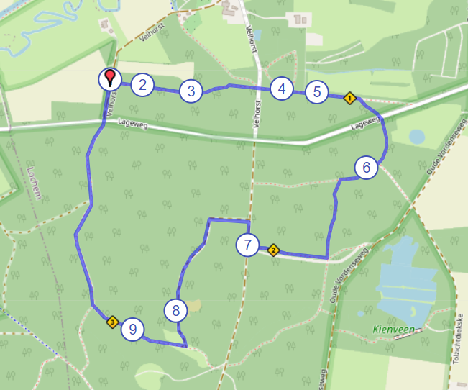
a screenshot of the walk

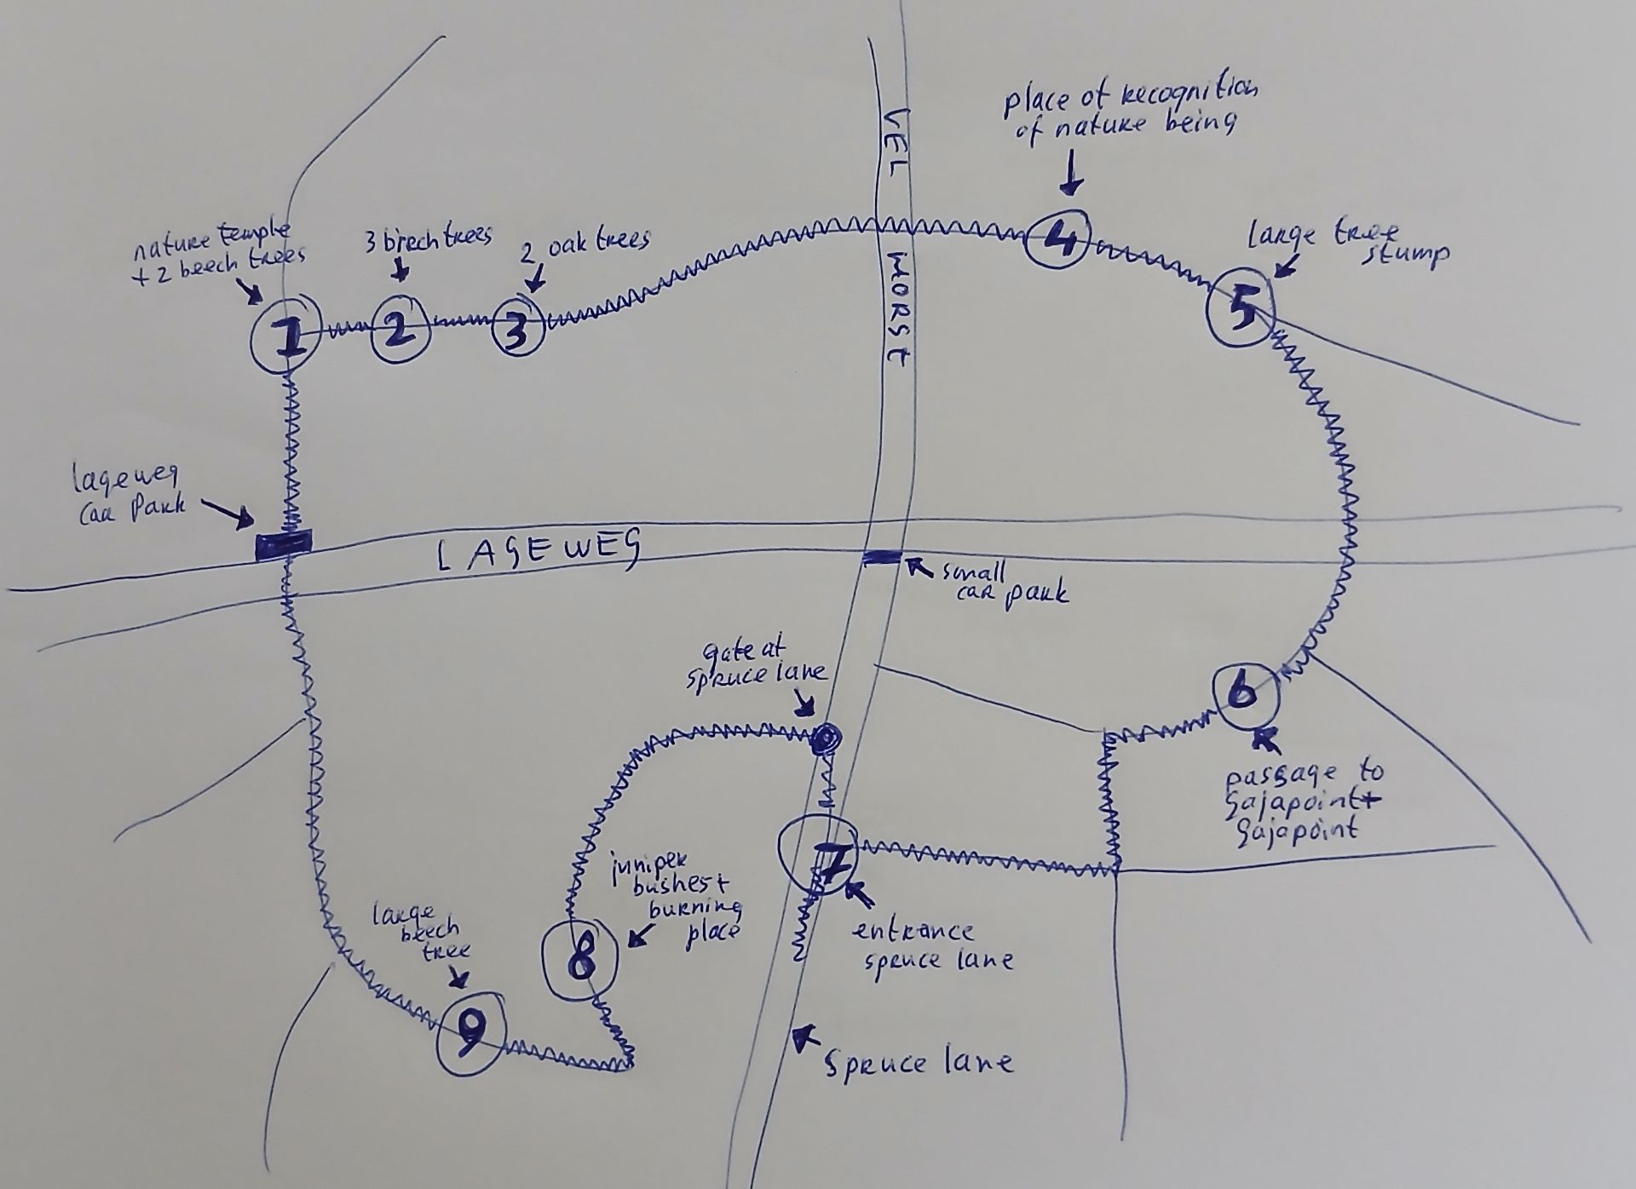
a drawing of the walk

Navigation
Enter ‘Lageweg car park’ (parkeerplaats Lageweg) into your sat-nav. The full address is: parkeerplaats Lageweg, Lageweg, 7241 TB Lochem.

This link will take you to the route on Google Maps: https://afstandmeten.nl/index.php?id=4157453, a screenshot of which is shown above.

Numbers 1 to 9 indicate nature spots along the route.
1. The nature temple and the two beech trees at the start
2. The three birch trees
3. The two oak trees
4. The place of recognition of nature beings
5. The large tree stump
6. The passage to the Gaja point and the Gaja point
7. The entrance by the spruce lane
8. The juniper bushes and, just behind them, the burning place
9. The large beech tree

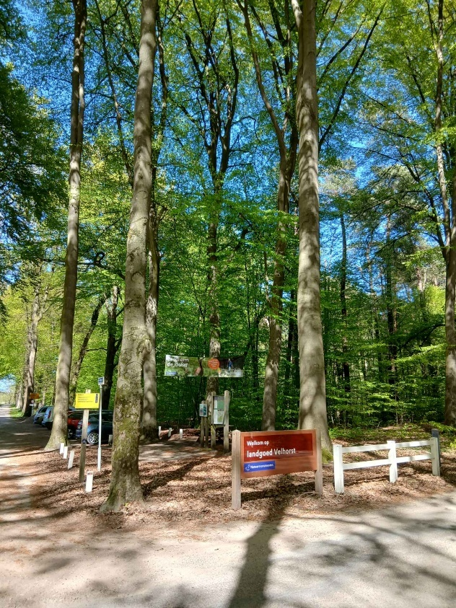
Lageweg car park

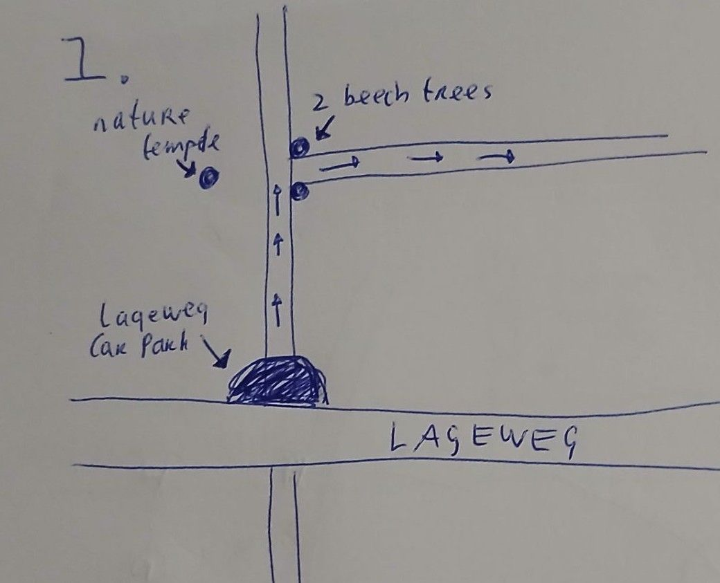
the car park, the nature temple and the two beech trees at the start

To the greeting of the nature goddess at her ‘temple’
From the Lageweg car park, walk into the woods. Take the path leading directly from the car park itself, not the one where you first have to cross the road.

A little further on, you see a path to the right. You’ll take that path shortly after you’ve visited the nature temple and paused by the two beech trees. At the entrance to that path on the right, you see two beech trees. These form the first actual nature spot on the Velhorst Crystalline meditation walk. Do not walk between the beech trees just yet. First, head to the natural temple located opposite these two beech trees, on the left-hand side of the path you are walking along.

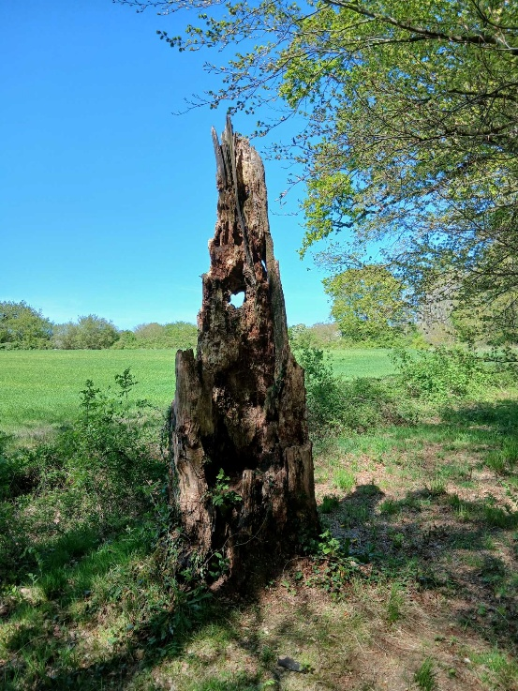
the natural temple

Greeting the nature goddess at her ‘temple’
Opposite the two beech trees, where the Velhorst Crystalline meditation walk begins, stands a small, natural ‘temple’. Traditionally, temples have served as a transitional space between the human world and the world of the gods. Temples are places that are also looked after from the spiritual world. The nature goddess associated with this place has an important role in the walk. She is the guardian of the meditation walk. She guides the entire route, particularly the nature spirits and natural spots. She also protects the latter. The temple forms a triangle with the two beech trees that mark the entrance. The nature goddess oversees everything.

If you wish to take the walk, you must present yourself to her. You give her a small gift. By giving a gift, you express your intention, and it is a gesture towards this nature goddess. You will receive much in return. Giving something means that you realise this, that you wish to open yourself up to it, and that you are grateful for it.

Your visit to the temple need not take long. A brief moment of contact, some attention and a gift are enough; nothing more needs to happen here.

Towards the entrance formed by the two beech trees
From the natural temple, walk back a few metres to the path you came from, and stop in front of the two beech trees that mark the entrance to the path you are about to take. Seen from the Lageweg car park, this is the first path on the right.

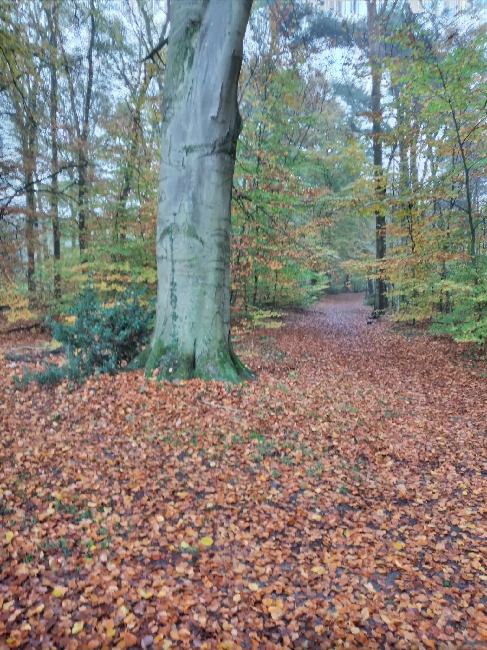
one of the two beeches
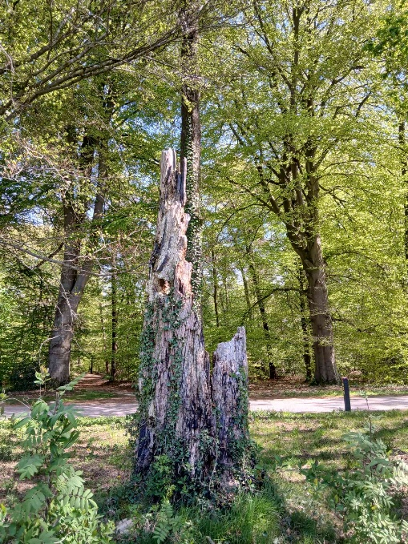
The two beeches are in the background. d.

The entrance of the two beech trees
Everyone who walks the meditation walk will receive a certain vibration from these two trees when walking between them, so that all beings involved in the walk know that you are there for this walk and will open up to you and help and guide you. So the beech trees give you a certain vibration that is characteristic of the Velhorst meditation walk.
You are invited to focus on one of the two trees. They both have a different effect, or gift, whatever you want to call it. The tree on the right focuses on seeing the beauty in everything. This gives you the strength to enjoy yourself, to open up, to be receptive. The tree on the left gives you the strength to truly surrender, to rise above yourself on this spiritual walk.

You can ask the beech tree you are focusing on for a message.

To the three birches
Distance: from the point between the two beech trees to the three birches: approx. 110 m.

Walk between the two beech trees and head towards the three birch trees, which stand on the left-hand side of the path. These three birch trees stand right next to the path and are close together. This makes them clearly visible.

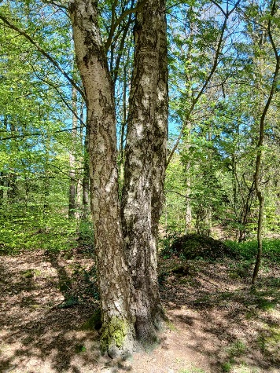
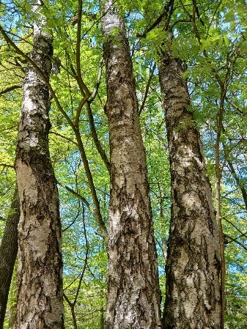
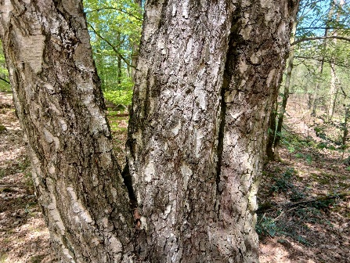
the three birches

The three birch trees
These birch trees welcome and embrace the people who are going to walk the trail with love, warmth, flow, joy, lightening their minds, freeing them from the worries of Earthly existence, allowing them to let go, forget and happily walk the trail. In doing so, they truly lighten your existence for a moment, catching you, embracing you.
You can ask the birch trees for a message.

Towards the two oak trees, the first transformation point
Distance: from the three birch trees to the two oak trees: approx. 170 m.

As you walk from the three birch trees towards the two oak trees further on, at some point you will see a meadow on your left, a little way off the path, peeking through the greenery. That meadow will serve as your landmark, letting you know that you need to keep an eye out for the two oak trees. When the meadow on the left ends, it is about ten metres further on that the two oak trees stand. They are also on the left of the path. Because both oak trees are just a little further off the path, they are less visible than the three birch trees you practically bump into. A small conifer stands next to them. The three of them are situated slightly higher than the path. If you stand on the path exactly where the two oaks are on the left-hand side, you will only see one oak because, from that position, they are standing one behind the other. The two oaks haven’t grown together, and you can stand between them if you like, or lie down or hang (together with the ground between them, they form a sort of hammock).

If you cross a small road and haven’t seen them yet, you’ve gone too far. You’ve missed them and need to turn back. The road crossing is about 200 m from the two oaks.

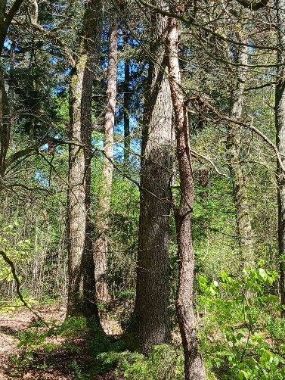

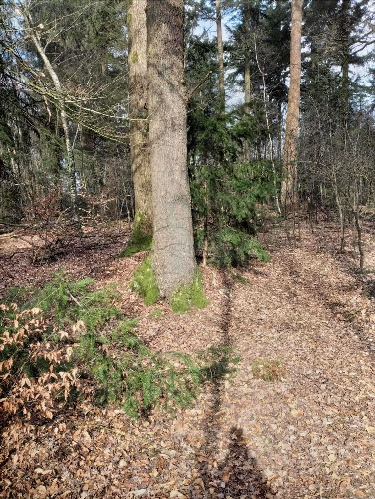
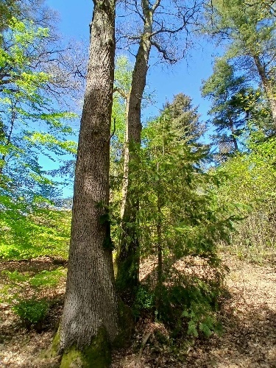
the two oaks (3X)

The two oaks, the first transformation point
The place actually transcends the oaks, but we speak from the perspective of the oaks. These two oaks demand great surrender from you. They place you in the power of your higher self. It is important to truly open yourself to this power, otherwise it cannot flow into you. You must consciously absorb this power that the oak trees have to give. Focusing on this requires an opening within yourself. Focus on your dignity and your higher self-awareness, where you stand above the world, above everything that happens.
This is about the greatness and dignity that everyone possesses as heavenly beings. The oaks bring us into contact with this higher being that we actually are and that we have forgotten. But they cannot do this properly if you are unable to open yourself up to it. The oaks truly connect you with your higher self, which knows no fear, knows no doubt, and is a pure, powerful self.
You can ask the oak trees for a message.

To the place of recognition of nature beings
Distance: from the two oaks to the place of recognition of the nature beings: approx. 270–280–290 m.

You walk on from the two oak trees and cross a road after approx. 200 m. The place of recognition of nature beings is on the right-hand side of the path. There are several small clearings amongst the rhododendrons that are suitable for this. From such a spot, you can see a few furrows in the ground running in both directions: towards the path and at right angles to it. If you have these in front of you, you’re in the right place. You have a few options for this.

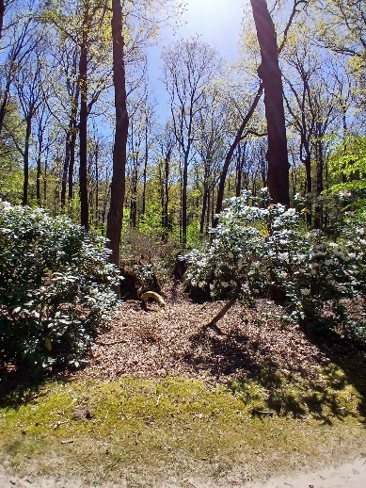

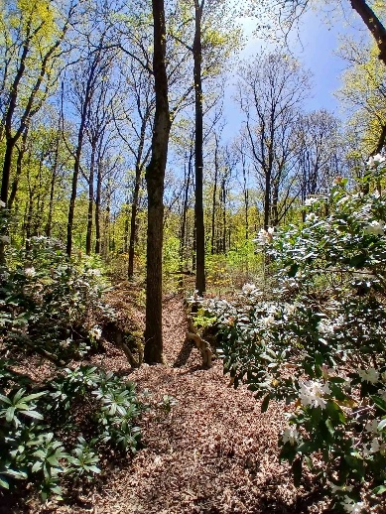
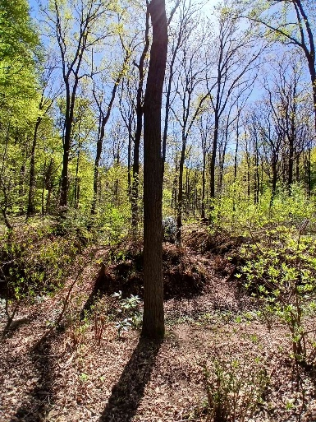
the place of recognition of nature beings (3X)

The place of recognition of nature beings
This is a surprising natural spot with vistas. The openness of this place also has an energetic effect. It offers a wonderful opportunity to come into contact with nature beings. Nature beings here are focused on making your consciousness more receptive to their existence. More recognition, the awareness that they are there, thinking about them more often: these are things you can imagine. We like to look at nature, the work of nature beings. If you look at nature, you may think of them more quickly next time. These moments of contact strengthen the bond between them and humans.
You can ask the nature spirits for a message.

To the large tree stump
Distance: from the spot of recognition of nature beings to the large tree stump: approx. 100 – 110 – 120 m.

Walk a little further down the path and you will see a large, low tree stump on the right-hand side, right next to the path. That’s the one.

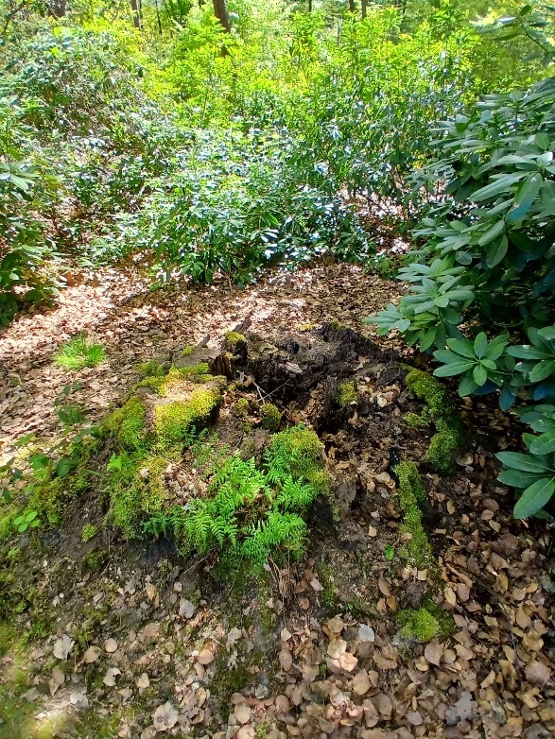

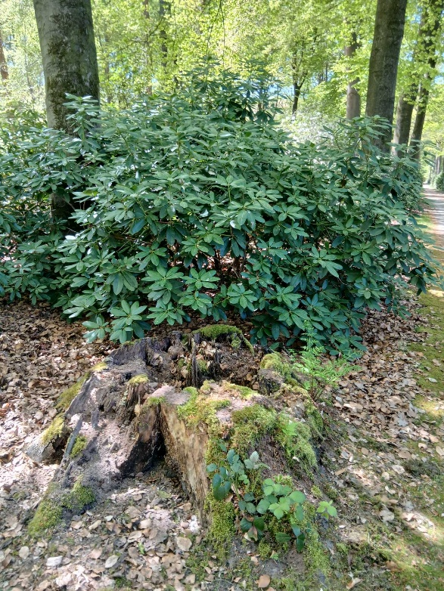
the large tree stump (2X)

The large tree stump
The large tree stump is the place where everyone likes to look at the large number of mushrooms in a large tree stump that is open inside, at least when it is the right time of year. At this tree stump, you can look at your own dark places in the past that you no longer need to be afraid of. This place helps you to see your dark places and say: “It's okay.” You feel that you no longer need to be afraid of them, that you no longer need to run away from anything. That is liberating. The place connects these dark places with strong earth forces.

To the passage to the Gaja point
Distance: from the large tree stump to the passage to the Gaja point: approx. 410 m.

Continue along the path past the large tree stump.

Turn right at a path that runs diagonally to the right, located approx. 120 m past the large tree stump.

Once you have turned right, you will soon come to a road crossing, which you cross. This is approx. 200 m past the large tree stump.

Continue along the path and at some point you will come across a path to the left which you do not take, but which does provide a useful landmark. That path to the left, which you do not take, is located approx. 360 m past the large tree stump. From this point, walk straight ahead, immediately up the small slope where the path to the Gaja point begins. That is why the path to the left is so useful: it helps you identify which slope is meant.

The passage to the Gaja point is formed by the top of the small hill and the path until you have descended the slope.

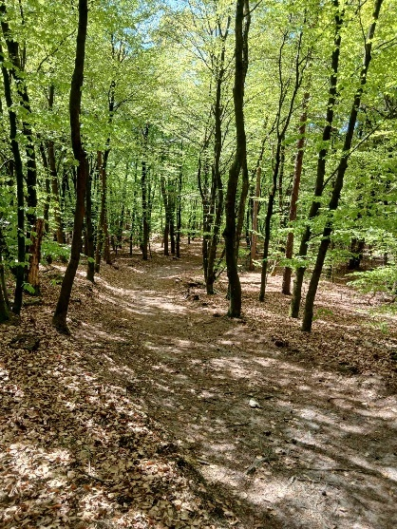

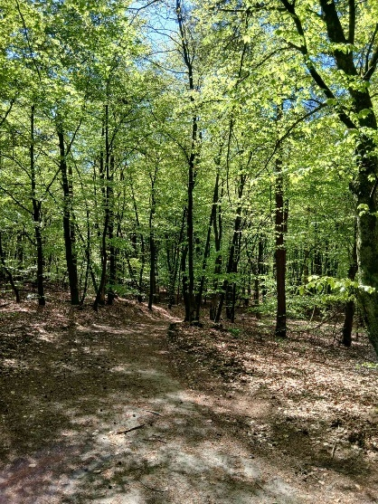
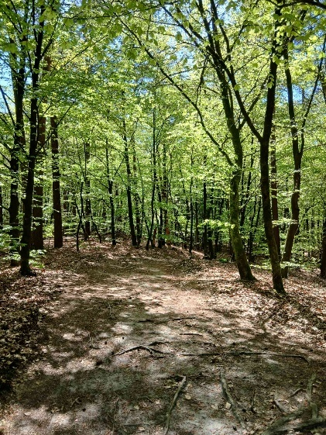
the passage to the Gaja point (3X)

The passage to the Gaja point
The passage to the Gaja point opens layer upon layer of gates of silence. So it opens, opens, opens layer upon layer, opens the gates of silence and you walk through them and go through all those openings. You should walk slowly through this passage so that the vibrations of the layers are absorbed into your system. You are, in fact, walking into the Earth's energy, towards the high consciousness of the Earth. That is an enormous being. If you want, you can stop here and there for a moment. It doesn't have to be long, but if you feel the need to do so, then do it. The passageway prepares you energetically for the Gaja event.

To the Gaja point, the second transformation point
Distance: from the start of the passage to the Gaja point itself: approx. 30 m.

At the bottom of the small hill and the patch of ground to its right is the Gaja point.

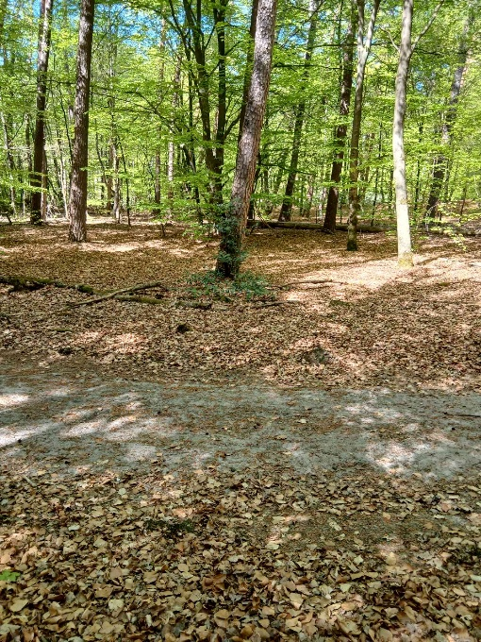

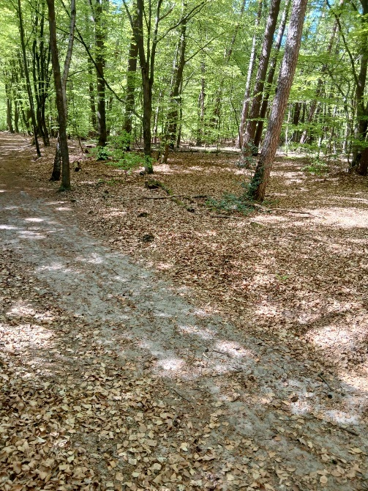
the Gaja point (2X)

The Gaja point, the second transformation point
The deva also watches the Gaja event with great admiration and respect. This is not part of her area of work, but is a gift from the Earth to her for the Velhorst meditation walk. The consciousness of the Earth rises there for this walk. That is fantastic. You unite with that. Becoming one with the Earth. The Earth opens up. Pure attunement for body, soul and spirit. Creates a feeling of home on Earth, of belonging. Very nice. Energies within you are harmonised with the process of the Earth and with the forces of the Earth. This is a very special gift, also for the deva, from the Earth. This all goes very deep and very far. The Earth is a very great and powerful being.
Here, the body can connect completely and become one with the Earth. This can have a purifying and helpful effect.
When you walk out, it closes again. But do this consciously. Leave this opened Earth that closes again consciously.

Towards the spruce lane, the third transformation point
Distance: from the Gaja point to the spot where you prepare for the spruce lane: approx. 530 m.

After the Gaja point, continue along the route. Turn left at the first path on the left. This is located approximately 30 m from the Gaja Point.

Then turn right at a junction, which is also the first path on the right. This is located approximately 300–310 m from the Gaja point.

If you carry on walking for a short while, you will eventually see the spruce lane ahead of you, which runs at right angles to the path you are on. Before you turn onto the spruce lane, prepare yourself and read the text next to it. So you don’t do this on the spruce avenue itself, but just before it. The instructions explain why this is the case.

On the spruce lane itself, find yourself a spot.

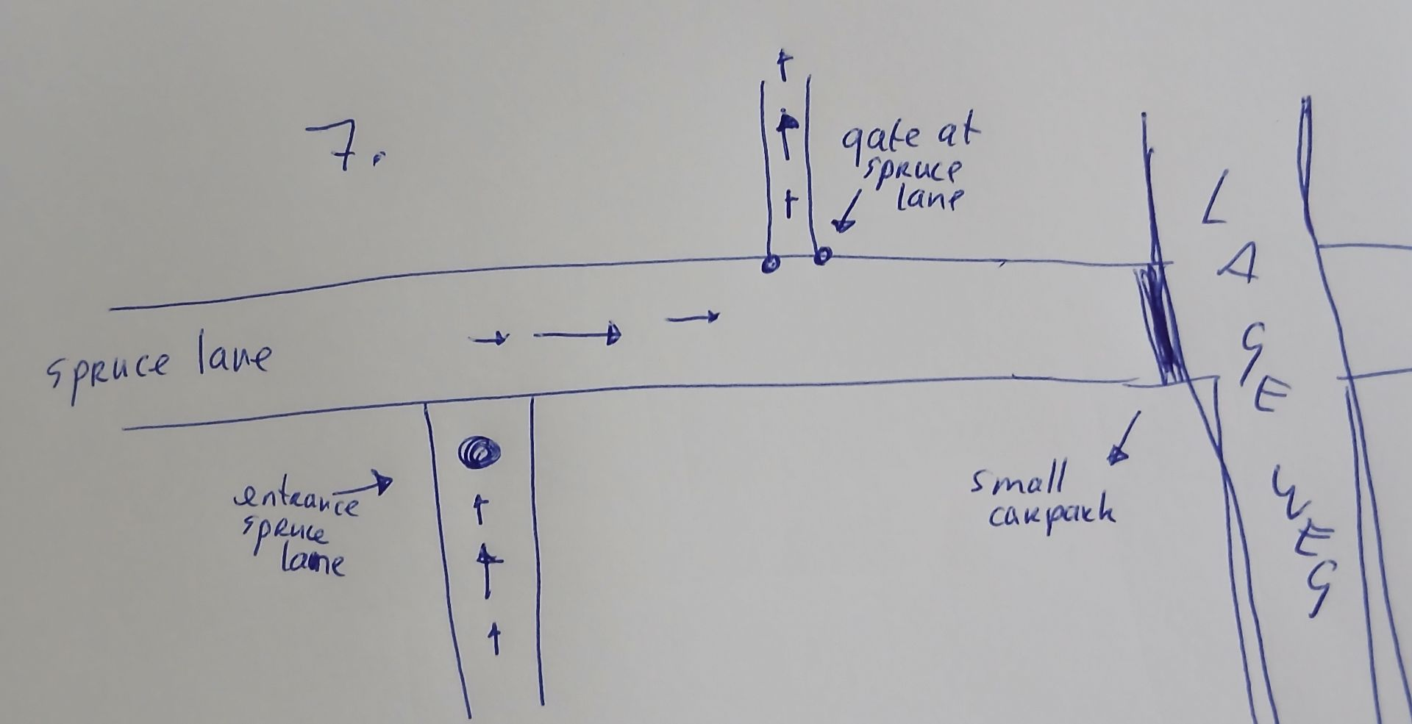
the entrance by the spruce lane, the spruce lane and the gate at the spruce lane

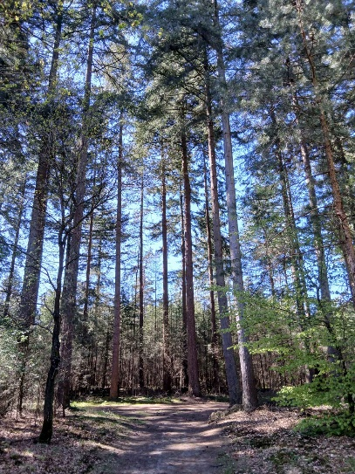
preparation spruce lane
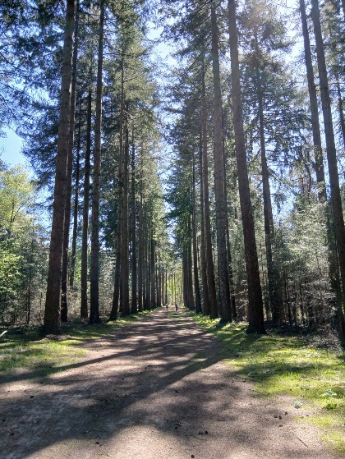
the spruce
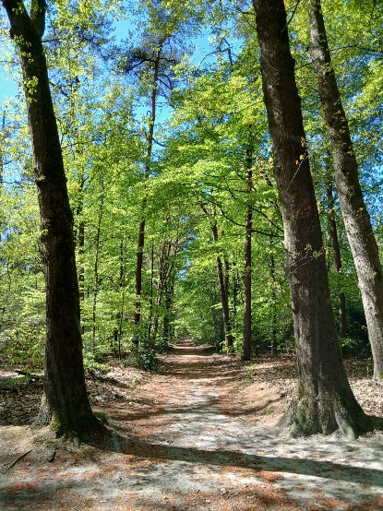
gate at the spruce lane

The spruce lane, the third transformation point
Just before the spruce lane, you pause and prepare yourself for what lies ahead. As you walk towards the spruce lane, you are immediately picked up and each person has their own beings who will help them through the spruce lane experience. Everyone is taken separately. Everyone gets several helpers because what is going to happen there is quite something. Everyone is welcomed and given individual attention. There is a programme on the spruce lane for everyone. On the spruce lane you will be connected to your cosmic self. In the light spheres, your self is always present. The part that incarnates is ‘only’ a part and never your entire self. You are connected to your cosmic part in the light spheres. Not everyone can be aware of this, as is also the case with other points of the meditation walk. If you do experience it, you may feel changed or renewed. Even if you do not experience it, it is still good to simply open yourself up and place yourself in a calm and quiet posture in which things can happen. It is a meeting place with your home being, which is elsewhere, in the spheres. You enter the light worlds where your soul core resides. That is why there is a separate programme for everyone, because everyone has their own sphere of light where their soul core is at home.
The information you receive here on deeper levels can be further processed by the juniper bushes that will do their work afterwards. Because contact with the soul core is very purifying, also for your DNA.
Here too, you consciously walk through a gate when you continue.

Towards the juniper bushes
Distance: from the gate at the spruce lane to the juniper bushes: approx. 440 m.

As you continue, looking from the path you came from, you turn right onto the spruce lane. So as you continue, looking from the spot where you prepared, you turn right. A little further on, there is a path to the left. (If you were to walk straight on, you would come out at a small car park.) At the entrance to that path there are two trees that form the boundary of spruce lane. Not an entrance gate, but a boundary gate. I call that spot the gate at spruce lane.

Continue along the path after passing through the gate at the spruce lane. After about 110–120 m, the path bends to the left. A little further on, you’ll go through a fence, which is located about 290 m from the gate on the spruce lane.

The juniper bushes you pass by for the meditation walk are on the left-hand side of the path, about 440 m from the gate of the spruce lane. After the fence, you’ll eventually see a fairly bare patch on your right. Once that ends, you’ll walk a very short distance with trees on both sides, and immediately after that there’s a bare patch on your left. The first group of juniper bushes there, which are closest to the path, are part of the walk.
But even if you don’t spot the juniper bushes straight away, or if you’re unsure, that’s no problem. Because after the juniper bushes is the burning place, and immediately after that you come to a T-junction. If you walk back from the T-junction, you’ll see the burning place to your right and the juniper bushes after that, also on the right-hand side.
You can’t miss it.

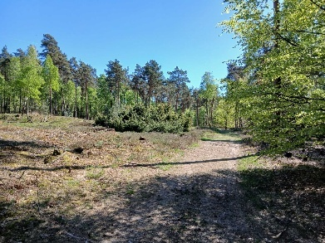
The group of bushes to the left of the path are the juniper bushes.
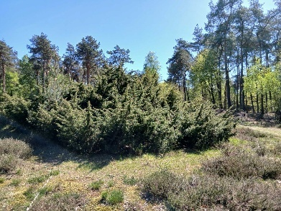
the juniper bushes
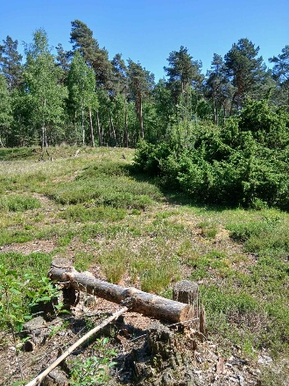
a sort of bench next to the juniper bushes

The juniper bushes
Here, everything that the juniper bushes receive in terms of high cosmic vibrations from your cosmic self, and your consent, is recorded in your cells and your DNA. DNA is your future. They also pull this future a few steps further into your system so that you can start functioning like that right away, immediately. Other adjustments to your system based on the vibrations from your cosmic self also take place here. Because apart from cells and DNA, there are more ‘storage systems’ within you that guide you and allow you to be who you are. This is very sophisticated and refined work. It is part of the juniper bushes' own ability; no separate being is connected to this that carries it out. It comes purely from the place of nature.
They have two functions for which they each need your separate permission: 1. Registering the new energies you have gained in your system, including in your DNA. 2. Already setting this new information in motion in your functioning system of thinking, feeling, willing and doing. It does this by immediately putting the first steps on the new path into action, they are already ‘burned’ into you, so to speak.

Towards the burning place
The burning place is located about 40 metres past the juniper bushes, also on the left-hand side of the path.

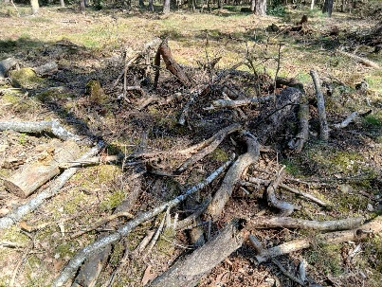
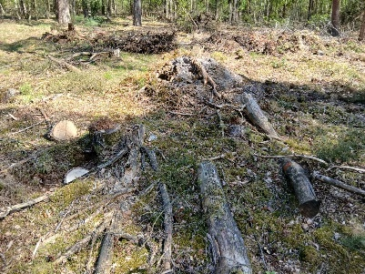

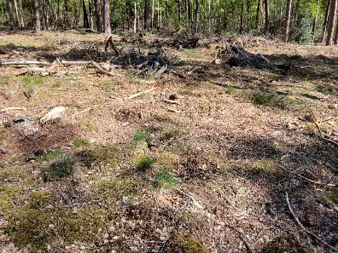
the burning place (3X)

The burning place
At the burning place, old energies that you no longer need are removed from your system. This takes time, more than you might think. You are probably not even aware of it. Allow yourself the space to do this.

To the large beech tree
Distance: from the burning place to the large beech tree: approx. 240 m.

After the burning place, carry on walking.

You will then very quickly come to a T-junction. Turn right there.

About 240 m after the burning place, you will see two groups of juniper bushes on the right-hand side of the path, with a tall oak tree between them. This oak tree stands against the group of juniper bushes bordering the path. The other group of juniper bushes stands slightly apart from it.

Once you have found this spot, you will also find the large beech tree. Opposite it, on the left-hand side of the path, stands the large beech tree. If it is not covered in leaves, you can see it. It stands a few metres from the path and has large, low-hanging branches. In summer, all you can see from the path are leaves.

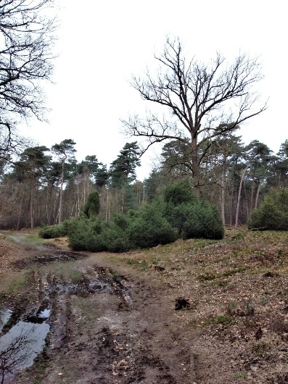

the oak with two groups of juniper bushes (the right one barely visible) opposite the spot where the large beech stands

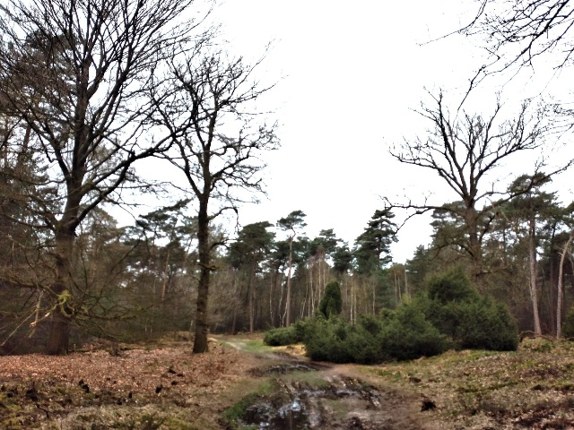
the oak with a group of juniper bushes and the large beech (the leftmost tree)

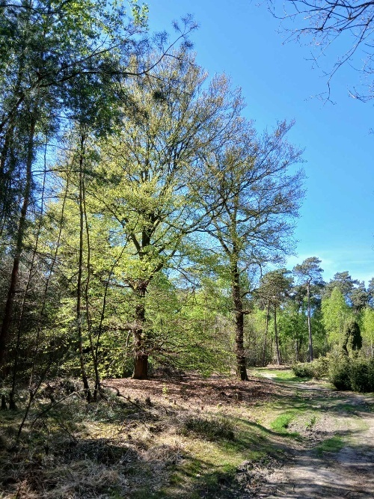
the large beech in the middle

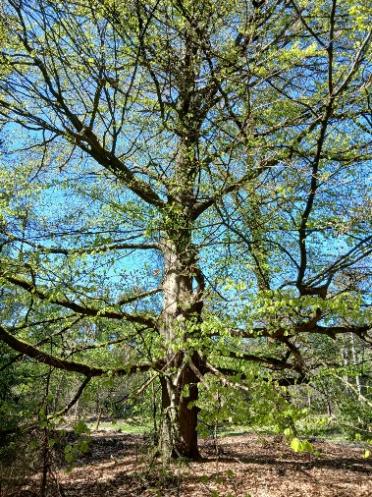

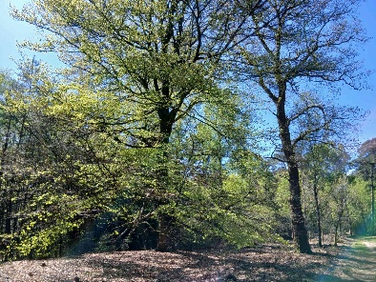
the large beech tree (2X)

The large beech tree
At this time, and for a long time to come, completely new energies are being sent into our cosmos, our universe and our planet. New to our cosmos, new to our universe, new to our planet, new to our bodies and our entire being. Energies that have never been here before. This is a very significant event. This beech tree is able to help our system attune itself to these new energies. Of course, this is already happening, as far as it is feasible for everyone's system. But in this place, you get extra help with this. This beech tree works on all levels within us: body, soul and spirit. This beech tree literally transports you into the future. It brings you into new energies that you were not yet attuned to. You will probably not notice much of this when you are in this place. Attune yourself to it when you are there, but that applies to every place. This beech tree creates new spaces within yourself and on Earth. This helps you get used to the new more quickly. It becomes easier and more normal for you; for example, talents and such are absorbed more quickly and you will find them ‘normal’ more quickly.

You can ask the large beech tree for a message.

Back to the Lageweg car park
Distance: from the large beech tree to the point where you can already see the car park: approx. 700 m.

From the large beech tree, continue along the path. A little further on, a path joins from the left; keep to the right. Almost immediately after that, you’ll see a fence which you pass through. Continue straight ahead.

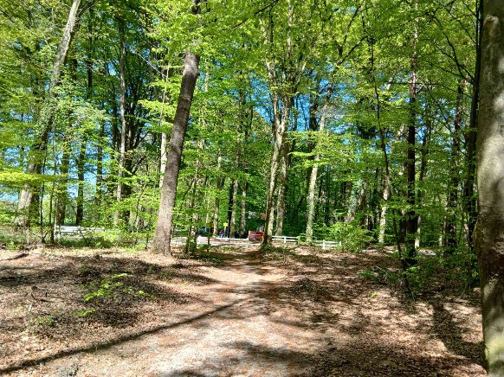
Lageweg car park in sight
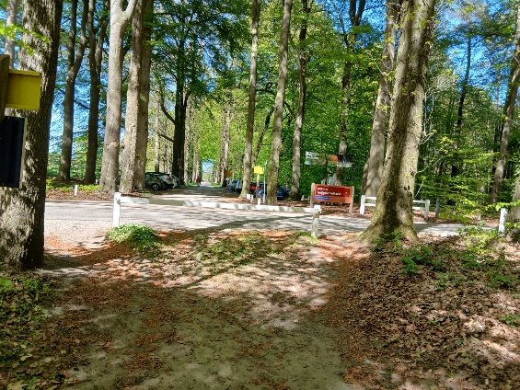
Lageweg car park

